What is IP?

Here, IP stands for **internet protocol**. It is a protocol defined in the TCP/IP model used for sending the packets from source to destination. The main task of IP is to deliver the packets from source to the destination based on the IP addresses available in the packet headers. IP defines the packet structure that hides the data which is to be delivered as well as the addressing method that labels the datagram with a source and destination information.

An IP protocol provides the connectionless service, which is accompanied by two transport protocols, i.e., [TCP/IP](https://www.javatpoint.com/tcp-ip-full-form) and UDP/IP, so internet protocol is also known as [TCP/IP](https://www.javatpoint.com/computer-network-tcp-ip-model) or [UDP](https://www.javatpoint.com/udp-full-form)/IP.

The first version of IP (Internet Protocol) was IPv4. After IPv4, IPv6 came into the market, which has been increasingly used on the public internet since 2006.

History of Internet Protocol

The development of the protocol gets started in 1974 by **Bob Kahn and Vint Cerf**. It is used in conjunction with the Transmission Control Protocol (TCP), so they together named the [TCP/IP](https://www.javatpoint.com/tcp-ip-full-form).

The first major version of the internet protocol was IPv4, which was version 4. This protocol was officially declared in RFC 791 by the Internet Engineering Task Force (IETF) in 1981.

After IPv4, the second major version of the internet protocol was IPv6, which was version 6. It was officially declared by the IETF in 1998. The main reason behind the development of IPv6 was to replace IPv4. There is a big difference between IPv4 and IPv6 is that IPv4 uses 32 bits for addressing, while IPv6 uses 128 bits for addressing.

Function

The main function of the internet protocol is to provide addressing to the hosts, encapsulating the data into a packet structure, and routing the data from source to the destination across one or more [IP](https://www.javatpoint.com/ip-full-form) networks. In order to achieve these functionalities, [internet](https://www.javatpoint.com/internet) protocol provides two major things which are given below.

**An internet protocol defines two things:**

* Format of IP packet
* IP Addressing system

What is an IP packet?

Before an IP packet is sent over the network, two major components are added in an IP packet, i.e., **header** and a **payload**.

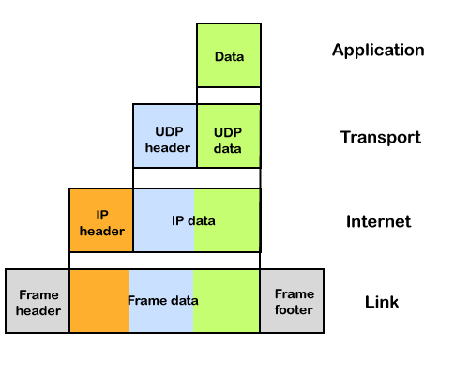

An IP header contains lots of information about the IP packet which includes:

* Source IP address: The source is the one who is sending the data.
* Destination IP address: The destination is a host that receives the data from the sender.
* Header length
* Packet length
* TTL (Time to Live): The number of hops occurs before the packet gets discarded.
* Transport protocol: The transport protocol used by the internet protocol, either it can be TCP or UDP.

There is a total of 14 fields exist in the IP header, and one of them is optional.

**Payload:** Payload is the data that is to be transported.

How does the IP routing perform?

IP routing is a process of determining the path for data so that it can travel from the source to the destination. As we know that the data is divided into multiple packets, and each packet will pass through a web of the router until it reaches the final destination. The path that the data packet follows is determined by the routing algorithm. The routing algorithm considers various factors like the size of the packet and its header to determine the efficient route for the data from the source to the destination. When the data packet reaches some router, then the source address and destination address are used with a routing table to determine the next hop's address. This process goes on until it reaches the destination. The data is divided into multiple packets so all the packets will travel individually to reach the destination.

**For example**, when an email is sent from the email server, then the TCP layer in this email server divides the data into multiple packets, provides numbering to these packets and transmits them to the IP layer. This IP layer further transmits the packet to the destination email server. On the side of the destination server, the IP layer transmits these data packets to the TCP layer, and the TCP layer recombines these data packets into the message. The message is sent to the email application.

What is IP Addressing?

An IP address is a unique identifier assigned to the computer which is connected to the internet. Each IP address consists of a series of characters like 192.168.1.2. Users cannot access the domain name of each website with the help of these characters, so DNS resolvers are used that convert the human-readable domain names into a series of characters. Each IP packet contains two addresses, i.e., the IP address of the device, which is sending the packet, and the IP address of the device which is receiving the packet.

**Types of IP addresses**

IPv4 addresses are divided into two categories:

* **Public address**
* **Private address**

Public address

The public address is also known as an external address as they are grouped under the WAN addresses. We can also define the public address as a way to communicate outside the network. This address is used to access the internet. The public address available on our computer provides the remote access to our computer. With the help of a public address, we can set up the home server to access the internet. This address is generally assigned by the ISP (Internet Service Provider).

**Key points related to public address are:**

* The scope of the public address is global, which means that we can communicate outside the network.
* This address is assigned by the ISP (Internet Service Provider).
* It is not available at free of cost.
* We can get the Public IP by typing on Google "What is my IP".

Private address

A private address is also known as an internal address, as it is grouped under the LAN addresses. It is used to communicate within the network. These addresses are not routed on the internet so that no traffic can come from the internet to this private address. The address space for the private address is allocated using **InterNIC** to create our own network. The private addresses are assigned to mainly those computers, printers, smartphones, which are kept inside the home or the computers that are kept within the organization. For example, a private address is assigned to the printer, which is kept inside our home, so that our family member can take out the print from the printer.

If the computer is assigned with a private address, then the devices available within the local network can view the computer through the private ip address. However, the devices available outside the local network cannot view the computer through the private IP address, but they can access the computer if they know the router's public address. To access the computer directly, NAT (Network Address Translator) is to be used.

**Key points related to private address are:**

* Its scope is local, as we can communicate within the network only.
* It is generally used for creating a local area network.
* It is available at free of cost.
* We can get to know the private IP address by simply typing the "ipconfig" on the command prompt.